
PRESS RELEASE Ostrava, 24th November 2015

MEGAPIXEL opened shop in Nová Karolina Park building

In the middle of November MEGAPIXEL s.r.o. opened its Ostrava branch at a new address, in the Nová Karolina Park building in the centre of Ostrava. Customers can find a wide assortment of digital cameras, video cameras and accessories, professional consulting and services on an area of 133 m² on the ground floor of the building, right by Karolina tram stop on Ostrava’s main street, 28. října.
In addition to office spaces Nová Karolina Park, an architecturally interesting office building, also offers retail spaces in an attractive location in a newly urbanised area of Ostrava. The traffic accessibility and location of the shop right in the centre of the city was important for MEGAPIXEL s.r.o.’s decision on the new site of the shop.
“The spaces in Nová Karolina Park fully met our requirements. We were looking for more square metres in order to implement a new retail concept while preferring a location near our original shop. In Nová Karolina Park we have found a location with excellent visibility and a naturally higher number of visitors. We will be open on weekdays from 9 a.m. to 7 p.m. and on Saturday from 9 a.m. to 12 p.m.” stated Ota Kaláb, the Chief Operations Officer of MEGAPIXEL s.r.o., with regard to the opening of the MEGAPIXEL shop in Nova Karolina Park

MEGAPIXEL s.r.o. has been involved in digital photography ever since 2001. It is one of the leading Czech vendors in this field and it is striving to expand the awareness of digital photography not only through selling products of the utmost quality, but also through consultation and workshops or courses held for amateur and professional photographers. It offers complete services, the possibility to rent a fully equipped atelier, equipment rental, the printing of photographs and second-hand sales.

The Nová Karolina Park office building offers 24 724 m² of office space and 3 824 m² of retail space, which is more than 70% occupied. NESS, Česká spořitelna, UniCredit Bank, UniCredit Leasing, ABB ČR and AXA ASSISTANCE, for example, are located in the office section. A pharmacy, flower shop and PRIM watch shop is located in the retail section on the ground floor of the building. Banks such as Česká spořitelna, Raiffeisenbank and UniCredit Bank have also opened branches here.

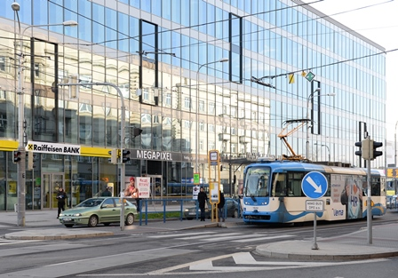

New MEGAPIXEL shop in Nová Karolina Park

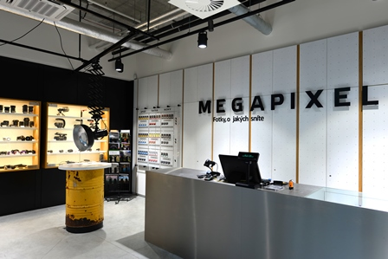

Interior of MEGAPIXEL shop in Nová Karolina Park

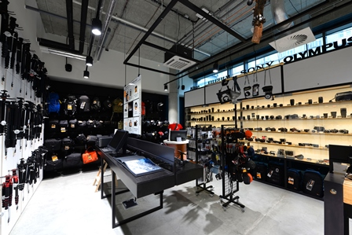

Interior of MEGAPIXEL shop in Nová Karolina Park

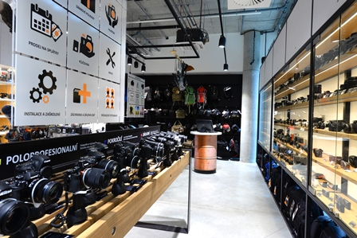

Interior of MEGAPIXEL shop in Nová Karolina Park

ABOUT THE NOVÁ KAROLINA PARK PROJECT
The Nová Karolina Park office building is sensitively located in a newly-urbanised area of Ostrava near Masarykovo náměstí and it forms a “gateway” from the historic core of the city. The developer of the project is a joint venture between PASSERINVEST GROUP and GEMO OLOMOUC. The project’s architectural design comes from the drawing boards of Vít Máslo and David R. Chisholm of CMC architects. The entire project is spread out over 32 hectares of space on six storeys and it offers almost 24,600 m² of prime office space. This is supplemented on the ground floor with 3700 m² of space suitable for shops, services and restaurants. There are 279 underground parking spaces meant for the users of the building. Nová Karolina Park is certified as a green building according to BREEAM (BRE Environmental Assessment Method). The British BREEAM certificate is a prestigious methodology for the certification of green buildings in Europe.

PASSERINVEST GROUP, a. s., is a purely Czech development company, whose name is primarily connected with the construction of the multifunctional BB Centrum complex in Prague 4 – Michle. The company, founded in 1991 by Radim Passer, built a very good name on both a domestic and international level with this, the most successful and extensive Czech project of its kind. This is not only due to the quality of the implemented projects and the high level of provided services, but also to a sense of fair play, an accommodating relationship with the tenants/users of the buildings and the responsibility towards society and the environment. PASSERINVEST GROUP also has other interesting development projects in its portfolio.

For more information and photographs in print quality please contact:
Mgr. Vendula Malochová, Marketing Manager
PASSERINVEST GROUP, a.s.
Tel.: (+420) 221 582 111, fax: (+420) 222 515 521
Mobile: (+420) 605 318 974
E-mail: vendula.malochova@passerinvest.cz
www.passerinvest.cz www.novakarolinapark.cz

Ing. Marcela Štefcová
Crest Communications a.s.
Tel.: (+420) 222 927 125
Mobile: (+420) 731 613 669
E-mail: marcela.stefcova@crestcom.cz
www.crestcom.cz

